**Mr. Montante**

**8th grade Social Studies Packet**

**Questions can be answered via email:** [**mmontante@nfschools.net**](mailto:mmontante@nfschools.net)

**Also you can join my Remind at the following website:** <https://www.remind.com/join/mrmontante>

**If technology is available at a later date you can do the same assignment online. I have detailed instructions on my webpage on the Gaskill website.**

**To complete this packet answer all questions in complete sentences. Please note any special directions on pages inside the packet.**

**Packet Objectives:**

* **Students can analyze the impact the War had on day to day life.**
* Students will examine the decision in Korematsu v. United States (1944) to intern Japanese Americans in light of perceived national security concerns versus constitutional rights.
* Students will examine American involvement in World War II including the American strategy in the Pacific and the invasion of Normandy on D-Day.
* Students will examine the air power by the allies, including use two atomic bombs on Japan.
* Students will investigate the Holocaust and explain the historical significance of the Nuremberg trials.
* Students will examine the structure and work of the United Nations.

**Day to Day Life in World War II**

Much like in World War I, the entire country had to shift the way it operated. Factories started being used to make war supplies, food was rationed in order to send extra food to the troops in Europe and the Pacific. To help make up the difference in food at home, people would grow a **victory garden** or little garden at home with vegetables. They would also can fruits and vegetables to keep it fresh, longer. Other things were rationed like gasoline. People were also encouraged to recycle things like grease and rubber so the military could use that.

The U.S. government was again trying to get support or this war and used propaganda to help get support. **Propaganda** is information, especially of a biased or misleading nature, used to promote or publicize a particular political cause or point of view, or put simply trying to convince you of something. If you recall from our World War Propaganda unit it can exist in all sorts of media, like cartoons, songs, news, articles, and posters. During World War II, the United States used all of these ways to reach and convince audiences to support the way.

Task: You will review 3 pieces of propaganda and determine its message and effectiveness.

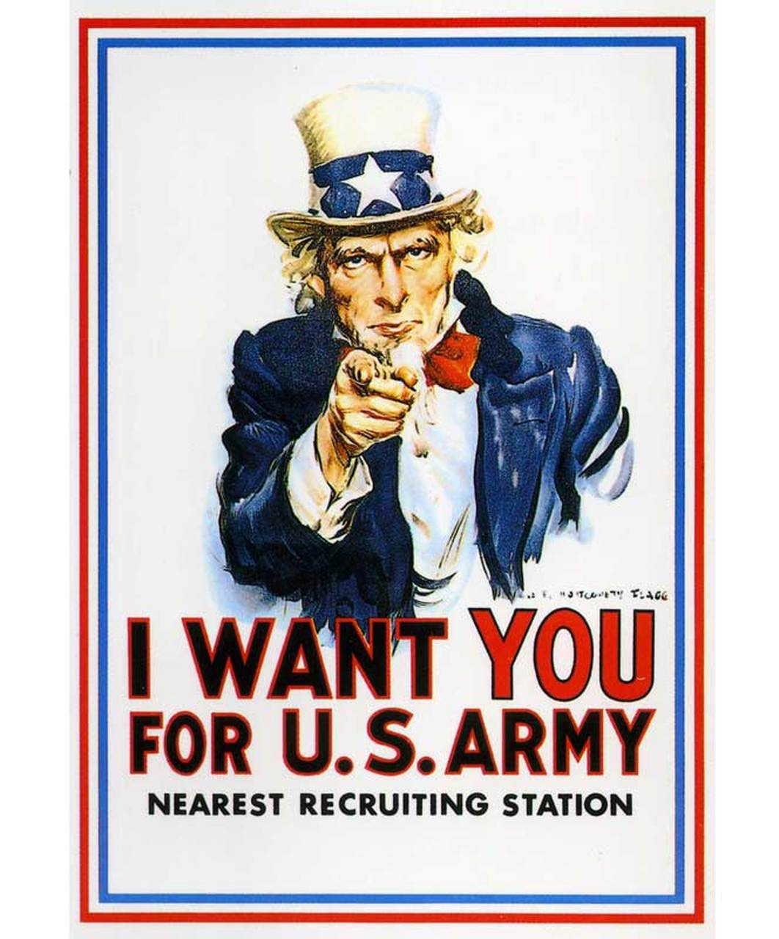

1) What is the propaganda piece’s message/objective? (What does it want you to do?)

2) Does the piece clearly convey the desired message? Why or why not?

3) Does the piece meet its intended message/objective? Explain.

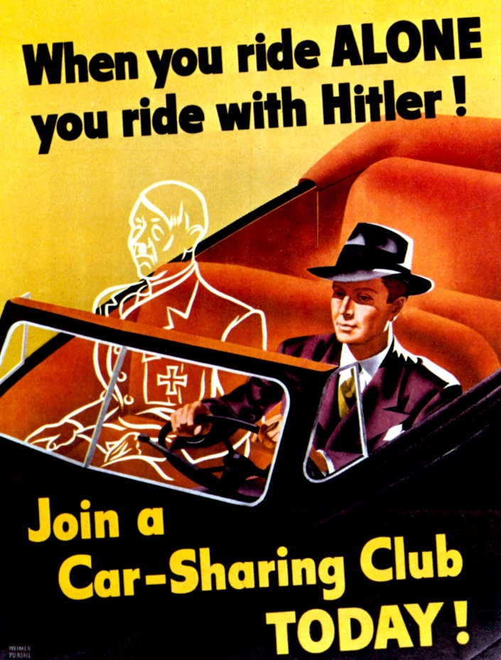

4) What is the propaganda piece’s message/objective? (What does it want you to do?)

5) Does the piece clearly convey the desired message? Why or why not?

6) Does the piece meet its intended message/objective? Explain.

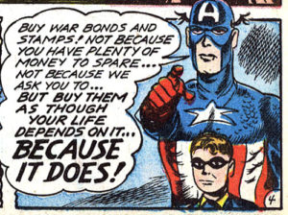

7) What is the propaganda piece’s message/objective? (What does it want you to do?)

8) Does the piece clearly convey the desired message? Why or why not?

9) Does the piece meet its intended message/objective? Explain.

**Korematsu v. United States**

Korematsu v. United States was a landmark United States Supreme Court. It concerned the constitutionality of military commanders, under an executive order by the President, which ordered Japanese Americans into internment camps during World War II. This was regardless of their citizenship.

In February of 1942, President Franklin Roosevelt issued Executive Order No. 9066. This gave military commanders the power to evacuate all persons considered a threat to national security from the West Coast of the United States to relocation centers.

10) Why did the United States want to round up Japanese-Americans? What event happened that caused distrust?

Fred Korematsu, a Japanese-American who was born in the United States, refused to comply with the order. He became a fugitive, but was arrested and sentenced to five years probation. He appealed his conviction with the Ninth Circuit Court of Appeals. After having his conviction upheld, the case was heard by the U.S. Supreme Court. In a 6-3 decision, the Court upheld his conviction and ruled the exclusion order was constitutional.

Decision

The question before the Court was did the President and Congress exceed their powers. Did they violate the rights of Japanese and American citizens of Japanese descent.

In the majority opinion by Justice Hugo Black, the Court ruled 6-3 that the need to protect the country from espionage outweighed the rights of Mr. Korematsu. The issue of discrimination against a person due to prejudice against his ancestry is not a factor. Neither is there any question of his loyalty to the United States. The sole issue is his refusal to comply with a legal order during a time of war.

11) Did Fred Korematsu win his appeal?

12) What the court ultimately say to explain their decision?

13) Do you agree with the court’s reasoning?

**Turning the Tides of War**

**European Theater**

The United States was late to the battles in Europe. The Nazis had been fighting and invading countries since 1939 and by the time the U.S. got there only Britain stood in Western Europe and Soviet Russia stood in Eastern Europe fighting off German attacks. After the battle of Stalingrad the Russian went on the offense to drive Germany out but a new plan was being discussed in Yalta by the leaders of the United States, Britain, and Russia. The new plan wasn’t just to drive Hitler out of countries but to crush Germany.

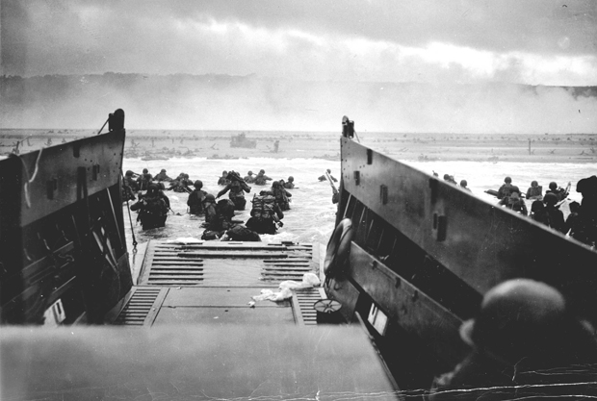 In order to do this they had to surround Germany and force a total surrender. Russia would continue to push from the East while the United States, British, Canadian, and French resistance forces would plan a secret invasion on the beaches of Normandy. On June 6th, 1944, boats crossed the English Channel to France. This invasion is called **D-Day** and thousands of men stormed the beaches and started a campaign that would change the war. While many men died on those beaches the allied invasion was a success because they were able to take the beaches. The beaches were just part 1, the allied forces then continued to chase German troops out of France and other countries they took over. Meanwhile, The U.S. started another campaign started in North Africa to deal with Italian and Nazi German troops. The U.S. drove back the army and pushed north into Italy and continued driving towards Germany. Germany now saw itself losing the war as it borders started to shrink from the West, South, and East.

1. What was the plan to make Germany surrender? Explain how this might have forced a surrender?
2. Was D-Day successful? Explain.

On April 30th, 1945, the Nazis were losing badly. Hitler knew it was the end, and he knew he would not survive as the details of his final solution for the Jews were being discovered (we will see that later in the packet). It is believed that Hitler killed himself that day. Germany now was left without the leader that created this war. On May 8th, 1945, nearly a year after the D-day invasion, Germany surrender, this day is known as V-E day in Europe. The war was over in Europe and the victors were Russia, Britain, and the United States. Germany lost, Hitler was dead. Italy, Germany’s ally was beaten and their leader was killed by his own people. Finally peace in Europe would come and it could started to be rebuilt. However, Europe severed as one of the chess boards the United States and Russia would play on in the decades to come after this war.

1. Who ultimately won the war in Europe?

**Pacific Theater**

Unlike the European War, the United States was on its own. In the Pacific it was a battle between the United States and Japan. The fights involved many naval and air battles in the vast ocean. Almost immediately after Pearl Harbor, the United States went on offense and Japan went on defense.

The United States plan was to bring the war to the Japanese main island. However, instead of sailing or flying straight there the United States had a strategy called **island-hoping.** The plan was to go to island to island in the South Pacific and defeat the Japanese troops there. This would weaken Japan and also give the United States abilities to create a place to refuel and resupply as they pushed closer to the main island.

1. What is island-hopping?

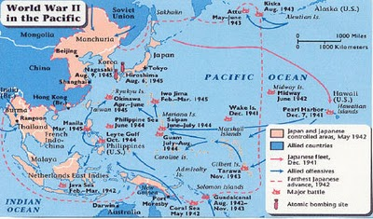The war in the pacific was bloody. Thousands of causalities piled up on both sides because of the Japanese no surrender attitude. If a Japanese solider knew he had no chance of winning he would rather go do killing as many enemies as possible. It was because of this the war and pacific took time and many victims. On the map you can see the United States (allied) offensives as they move closer to Japan.

1. Why did Island-hopping take time and carry a risk?

The United States were very close to the main island of Japan after a battle at Okinawa. They were planning to launch a full scale invasion on the main island to force Japanese surrender but because of Japan’s attitude about surrender they projected causalities of this invasion were high on both sides. The United States was hoping for a different solution.

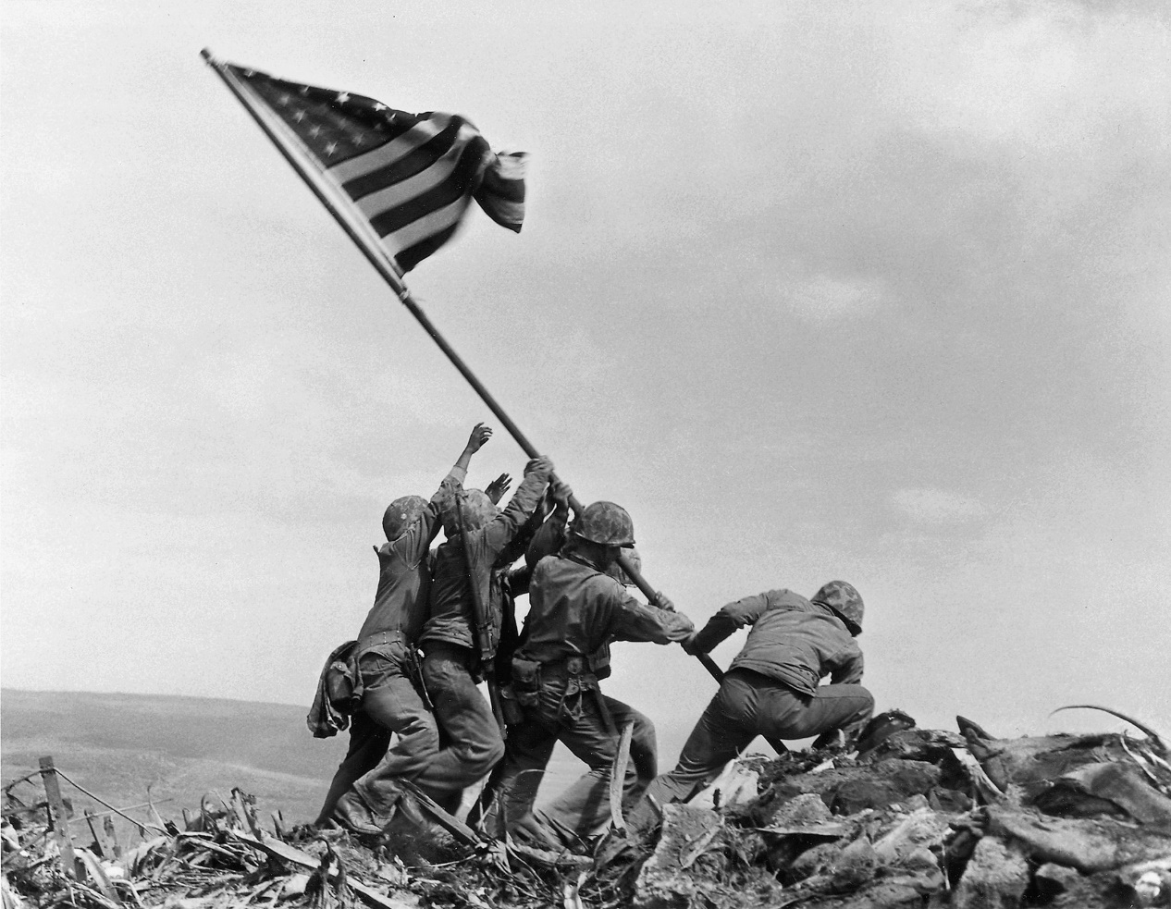

**US Troops raising the flag after a fierce battle on the island of Iwo Jima**

**ATOMIC BOMBS**

An atomic bomb is a wildly powerful weapon, sometimes called a nuclear bomb or nuke. The United States was developing this weapon during World War II because the Nazis were close to making one. The war in Europe ended before the bombs completion so it was never used in Europe. However, during the summer of 1945, war was still happening in the Pacific Ocean against Japan.

The United States successful made 3 bombs. They test one in the Southwest deserts of America. Now huge debates occurred with what to do with the last 2 bombs. Many within the military wanted to use it on Japan. They were sure that the powers would be powerful enough to force Japan to surrender. Military leaders also did not want to send in thousands of men to their death with an invasion of Japan.

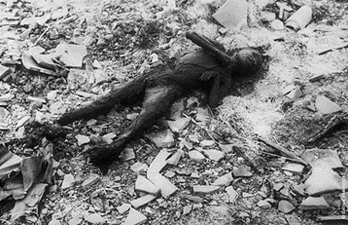On August 6th, 1945 the United States drop an atomic bomb on Hiroshima, a city in Japan. 135,000 people (over half the city’s population) either died or suffered severe injuries in the bombing. Most of these people were civilians, not in the military at all. Three days later, with no Japanese surrender announced, the United States dropped a second bomb on the city of Nagasaki. It is believed the bomb malfunctioned and only partially exploded but 64,000 people still died or were hurt in the explosion. This number again is mostly civilians. Finally Japan realized they could no longer win this war and that their honor was not worth the lives being lost and they surrender to the United States. The United States won the war and became the first country to use an atomic bomb in war. They were now an extremely powerful nation and the whole world knew it.

The decision to use these weapons is still debated to this day: The United States wanted to prove to Russia how strong it was. Japan was encouraging women and children to pick up sticks and fight the U.S. soldiers if they invade. Death toll predictions were high if there was an invasion for both side. Did dropping these bombs actually save more lives than what would have been lost in an invasion? Was it payback for Pearl Harbor? Should Japan have surrender earlier? Should it have been on non-civilian locations?

Those are all points or question made during the debate. Now it’s your turn to join this debate.

1. Do you think dropping the bomb was the right decision? Use complete sentences and explain your reasoning.

**The Holocaust**

Often consider the worst thing in human history even more so than the atomic bombs is the Holocaust. The Holocaust refers to Adolf Hitler’s final solution for the Jewish population. As we initially discussed, Hitler hated Jews and blamed them for all of Germany’s economic problems. He was able to convince most of the population that Jews were evil and should be viewed as less than human.

As Hitler rose to power he forced Jews to wear the Star of David so you could be identified as Jewish. He made them live in very awful parts of town called ghettos. Since Hitler controlled the state he controlled the police so Jewish people had no safety from the hate people started to display to them.

1. How did Hitler treat the Jews as he rose to power? Explain.

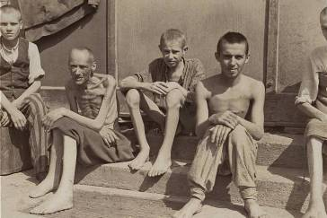As the war started things only got worse for Jewish. They started to be rounded up and sent off on trains, very often in the middle of the night. Some Jewish people were lucky and escaped the country, many unfortunately were sent back to Germany. Some went into hiding like Anne Frank and her family, others maybe had non-Jewish friends that hide their children in plain sight by asking the family to take them in and pretend they are their own. Most Jewish people in Europe were affect by this **Final Solution**.

As most Jews were rounded up they were placed at **Concentration Camps**. These camps were for Jews and prisoners. Once there the Jews were stripped naked and sorted. Those unable to work (young children and old people) were sent off to death immediately, normally in a chamber that released poisonous gas. Those who did not die would be put to work, hard work. The Jews were fed very little, typically old soup or moldy bread. Jews would die from exhaustion, starvation, or just losing their will to go on. The bodies of the dead were either buried or burned in furnaces. Families would arrive together but often not leave or if they survived not leave together. Hitler was in charge of one of the worst **genocides**, or mass murder of people based on race, religion, or ethnic background. The Holocaust claimed the lives of an estimated 6 million Jews and 5 million prisoners and other victims Hitler persecuted.

1. How might you feel if you were in one of these camps?

Most camps were in Eastern Europe. As the Russians won more battles they would discover these camps and the horror that laid in there. The discovery of these camps was probably a huge reason Hitler decided to kill himself, he knew he would be hung anyways. Most Nazi officers were tried after to war at the **Nuremberg Trails**. Those found guilty for crimes against humanity and violation of human rights were sentenced to death.

1. What happened at the Nuremberg Trails?

**The United Nations**

Many countries involved in the war realized Hitler and the war he created was not just a random assortment of accidents. They realized the treaty from the last war was tough and helped feed into Hitler’s rise. They also realized that the League of Nations was a failure. The League of Nations was an organization that was supposed to keep international peace. The United States did not join it. This time around the United States would join. A new organization called the United Nations came to be. The purpose of the U.N. was to make sure another World War like this happened again. They were going to keep peace. The also wanted to ensure there would never be a genocide like the Holocaust. They were going to protect human rights. The U.N. was huge in creating a Jewish homeland after the war in Israel.

1. What are the purposes of the U.N.?

The thing that made the United Nations more powerful than the League of Nations was actually having a military task force that could do something about a country over stepping its borders or a leader violating human rights. The U.N. military task force has been used several times since its creation, probably most notable from a U.S. history perspective in the Korean War and Desert Storm.

1. What made the United Nations different from the League of Nations?

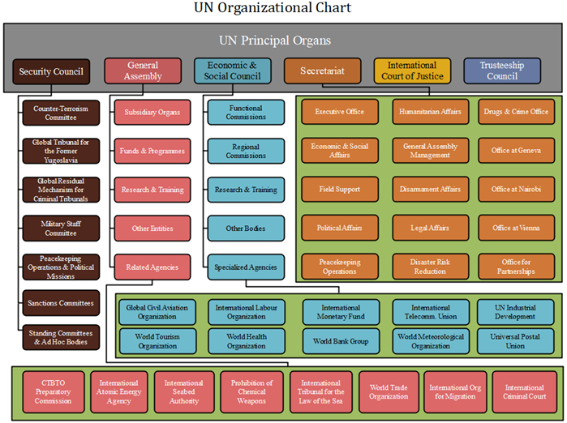

How does the U.N. work? Different “organs” handle different responsibilities. A country and could often been on multiple “Organs”. Each organ works differently. Some have elected positions while others do not. The United Nations headquarters is in New York City.

**STOP!! Submit this by 5:00 pm Friday May 22nd.**